**Exercise 1**

Step1-2:

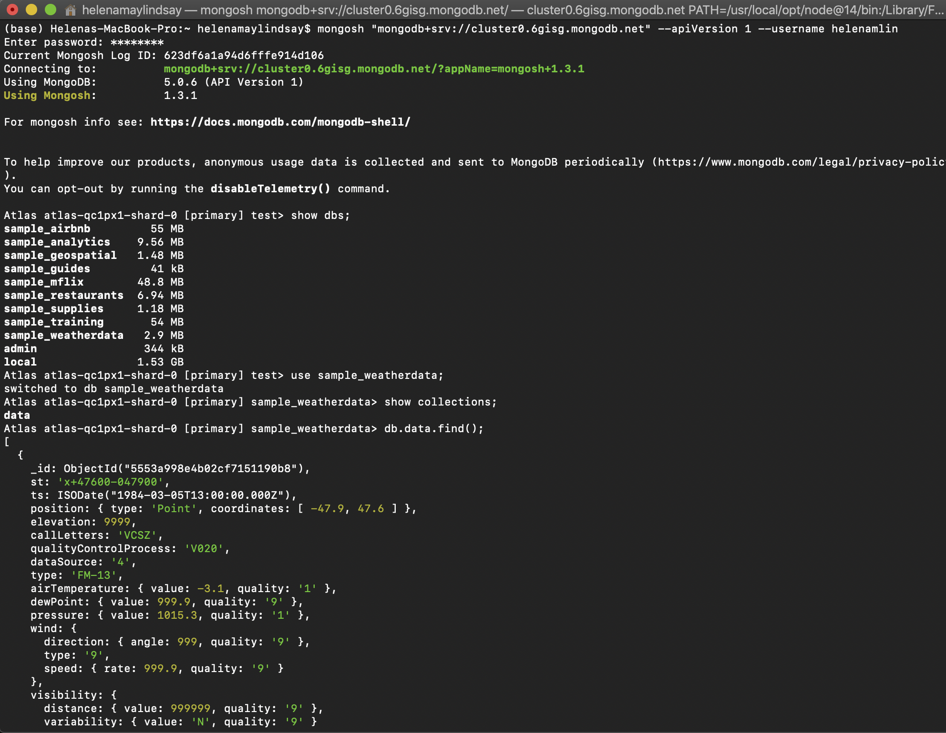

Step 3-4:

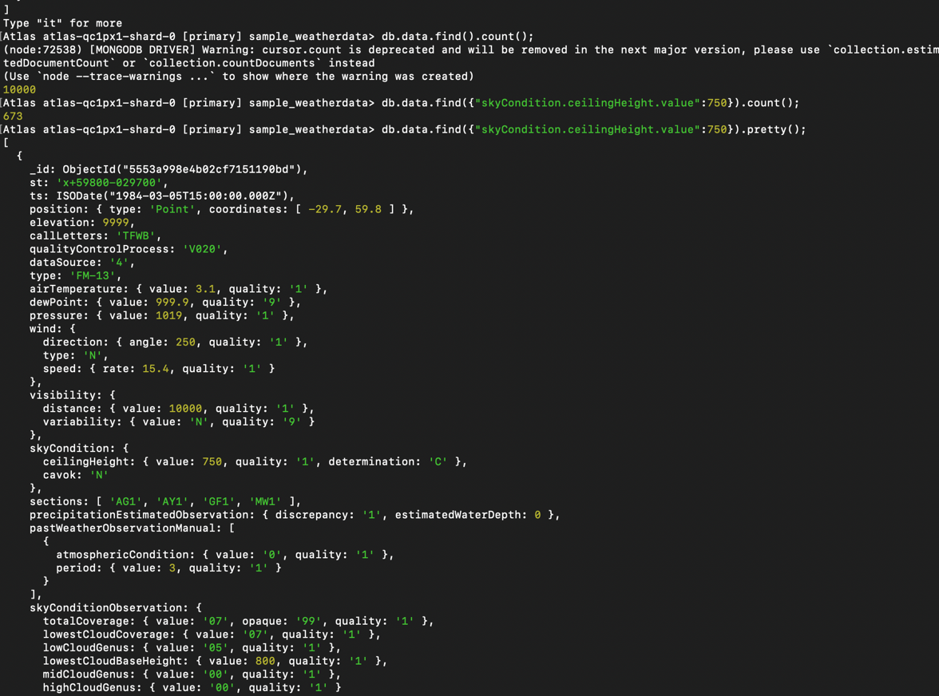

Step 5:

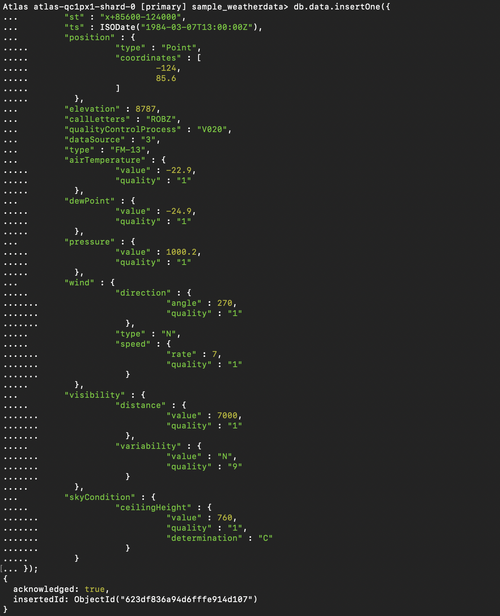

Step 6: (Finding the newly inserted document)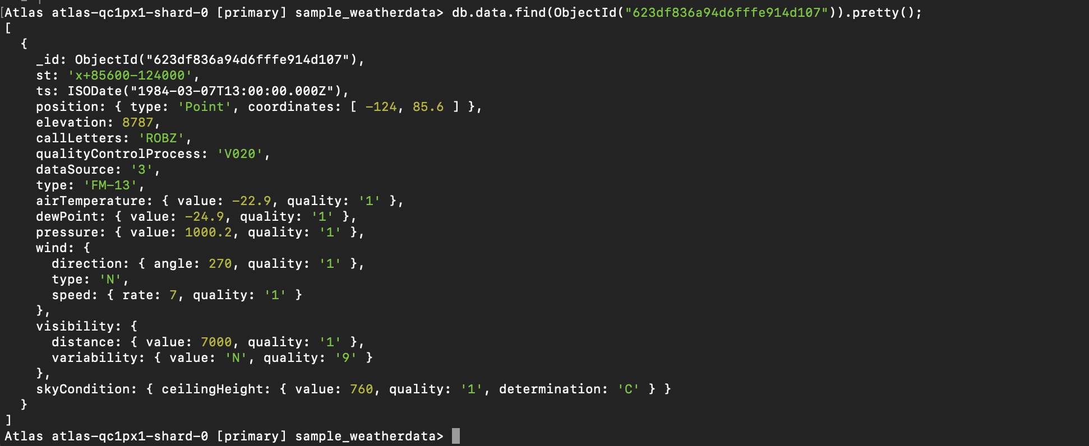

**Exercise 2**

Step 1-4:

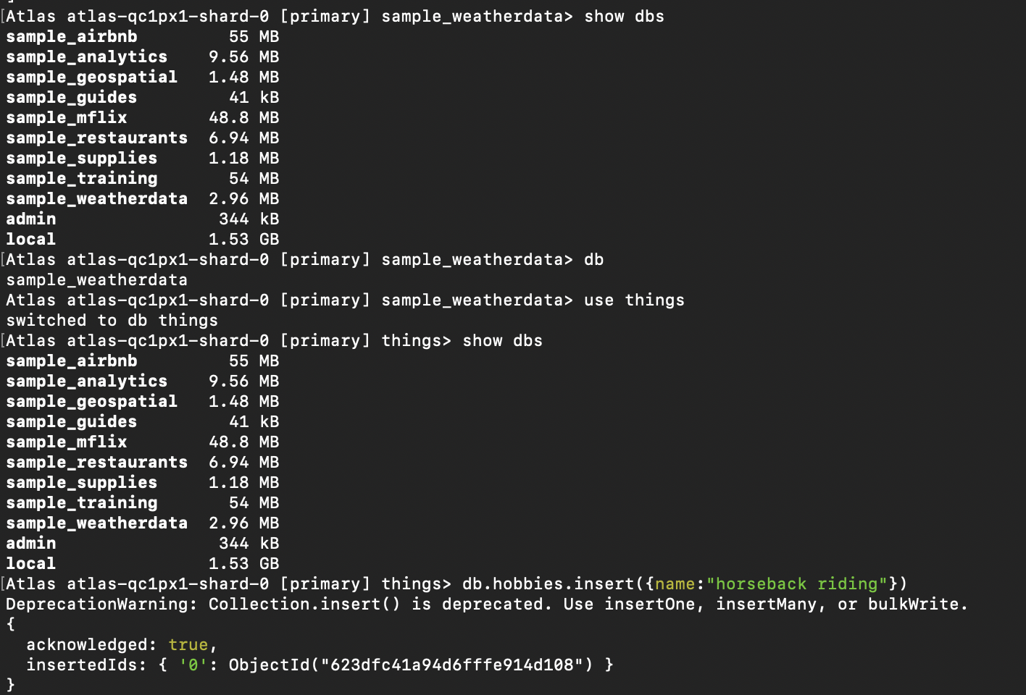

Step 6-7:

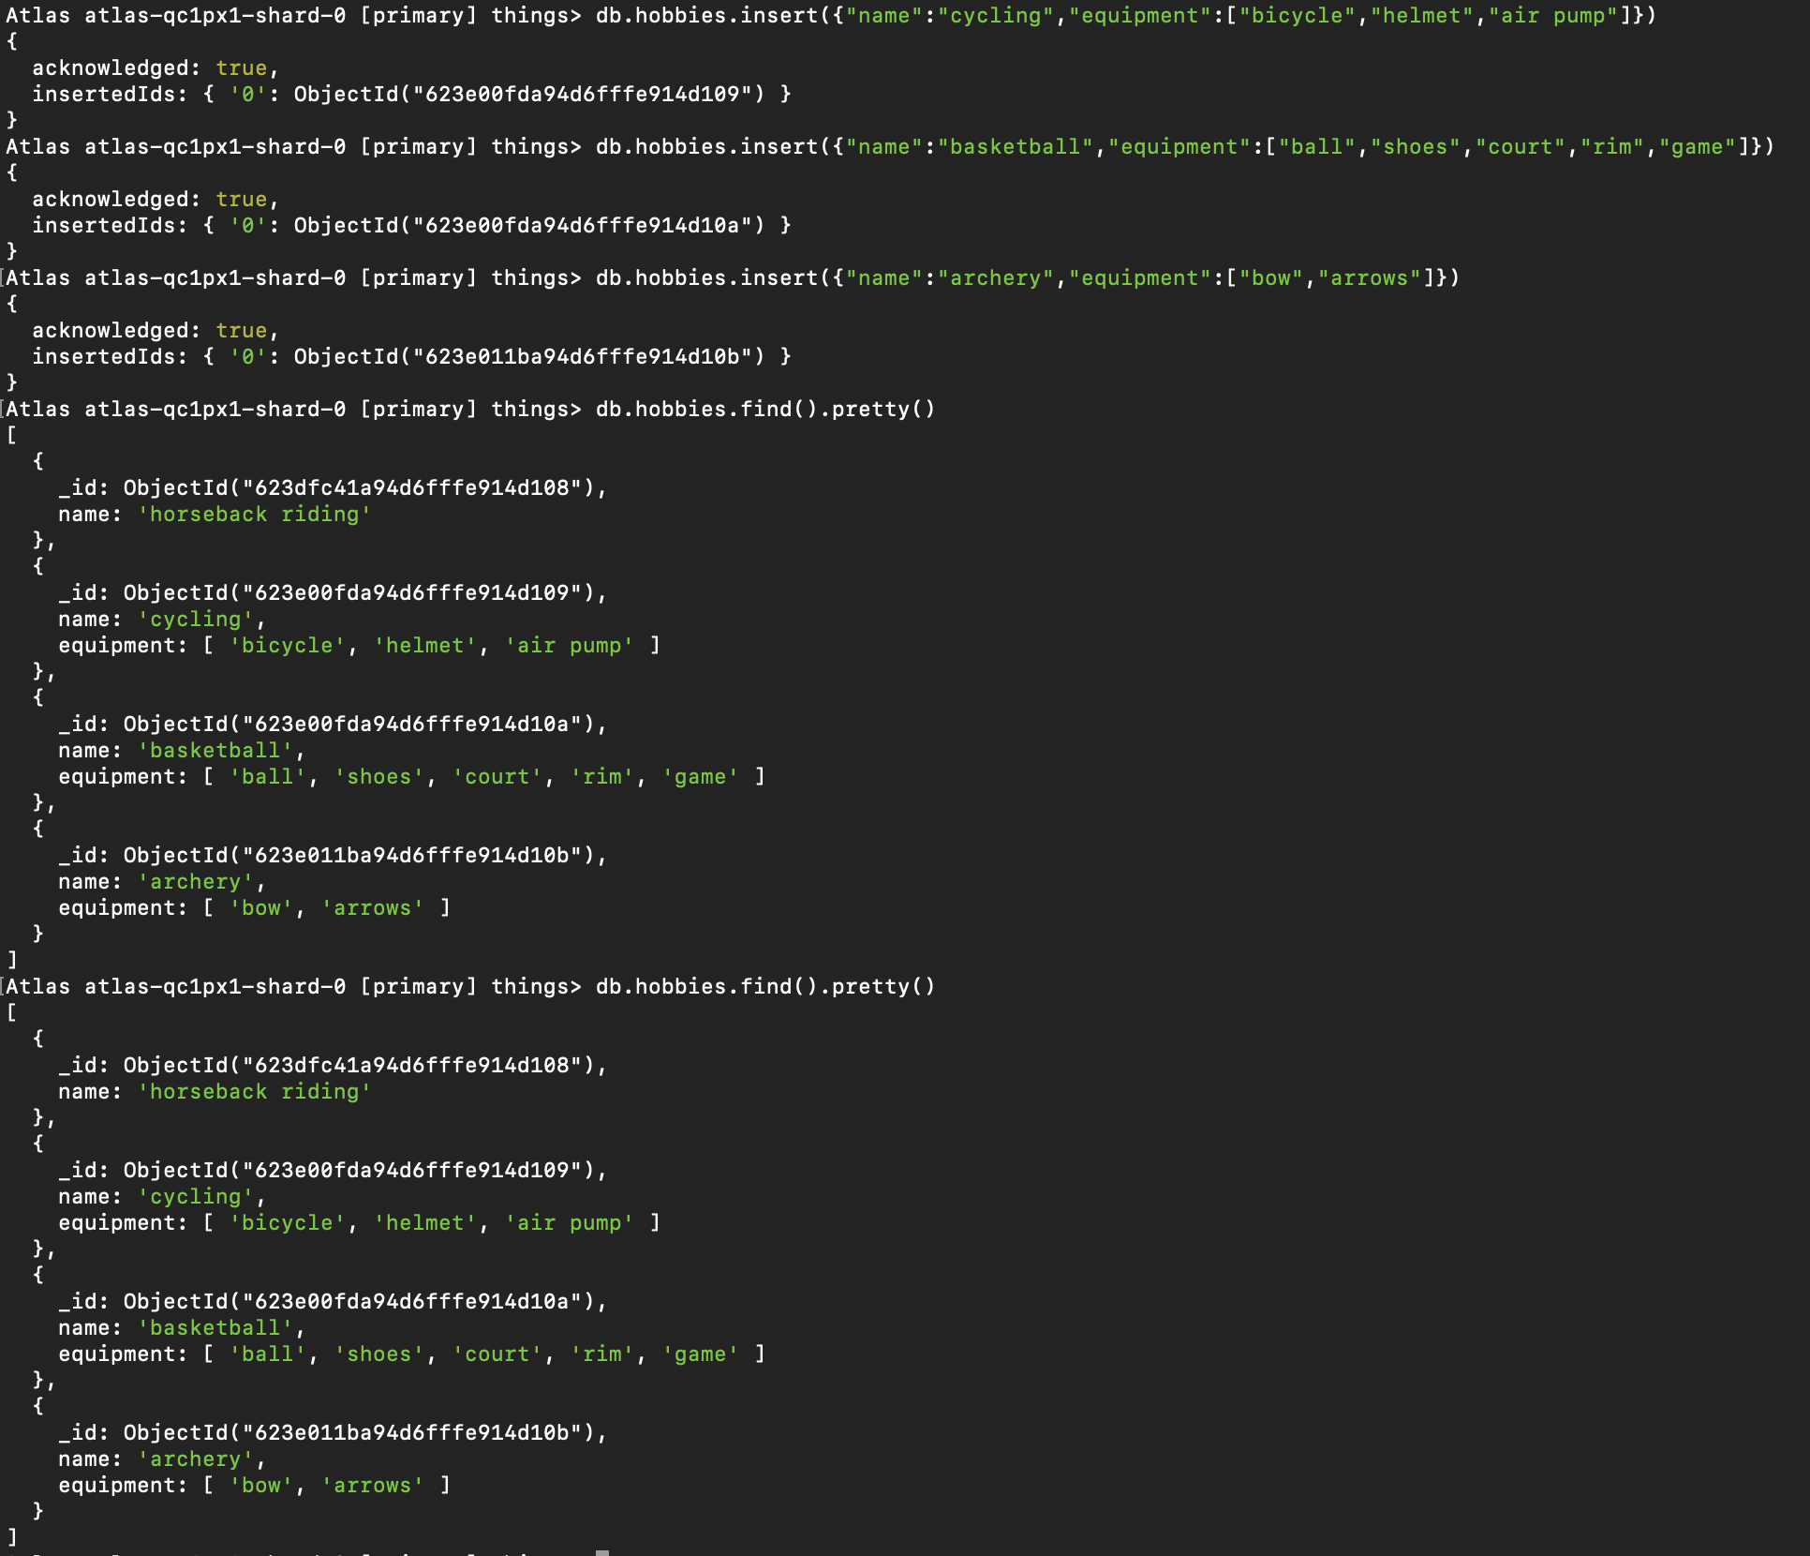

Step 8-9:

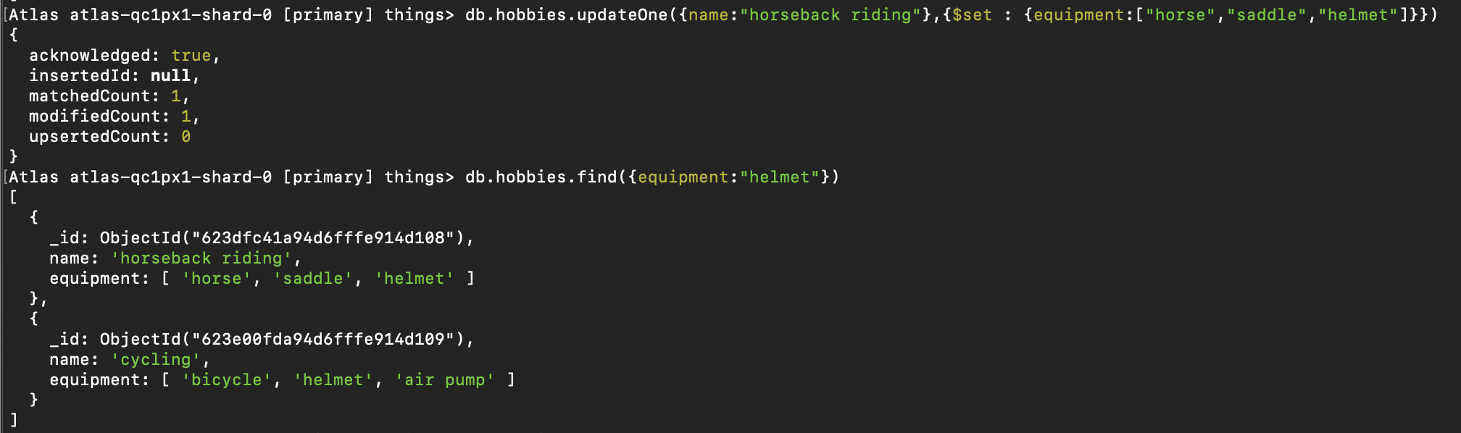

Step 10:

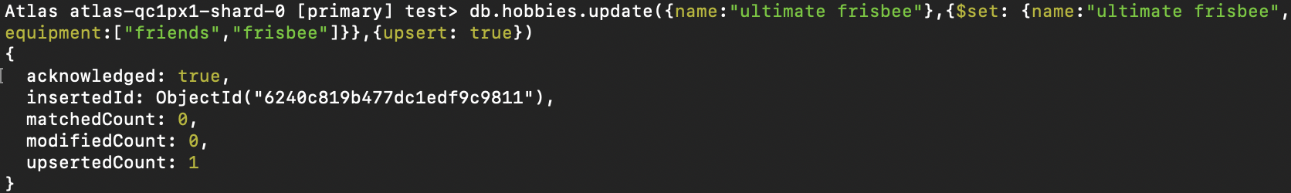

Step 11:

